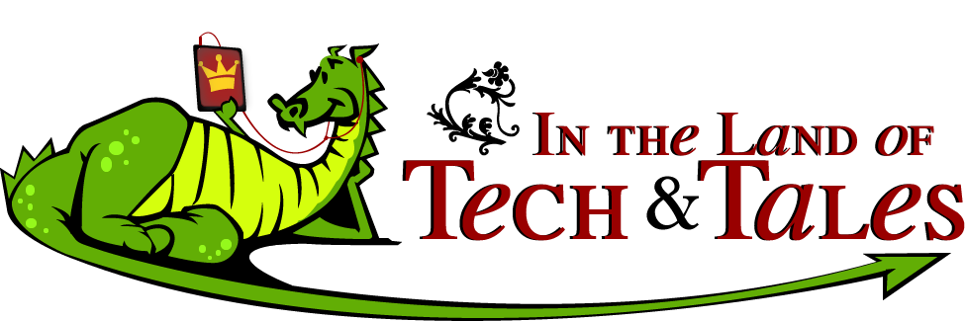

Once upon a time, in the Land of Tech & Tales, there were iPads, QR Codes, and GPS devices.
WHAT?!? Technology and fairy tales?
Think about it…
Just imagine how much easier it would have been for Hansel and Gretel to find their way home if they had a GPS instead of those crazy bread crumbs. What if the Wolf was not just a bully, but a cyber bully (Three Little Pigs)? What if Jack had scanned the QR code on the back of the bean seed package and found out they weren’t ordinary beans?

Engage in scavenger hunts and noble quests using GPS devices and QR codes.
Create and publish a digital fairy tale using a “magic Apple” (iPad).
Explore the world of fairy tales with a fun technology twist!
Thursday, May 24…..9:00-3:30…..4th-6th grades…..Wilson
Cost for this Happily Ever After is $35
Return the attached application and money by May 18.

