
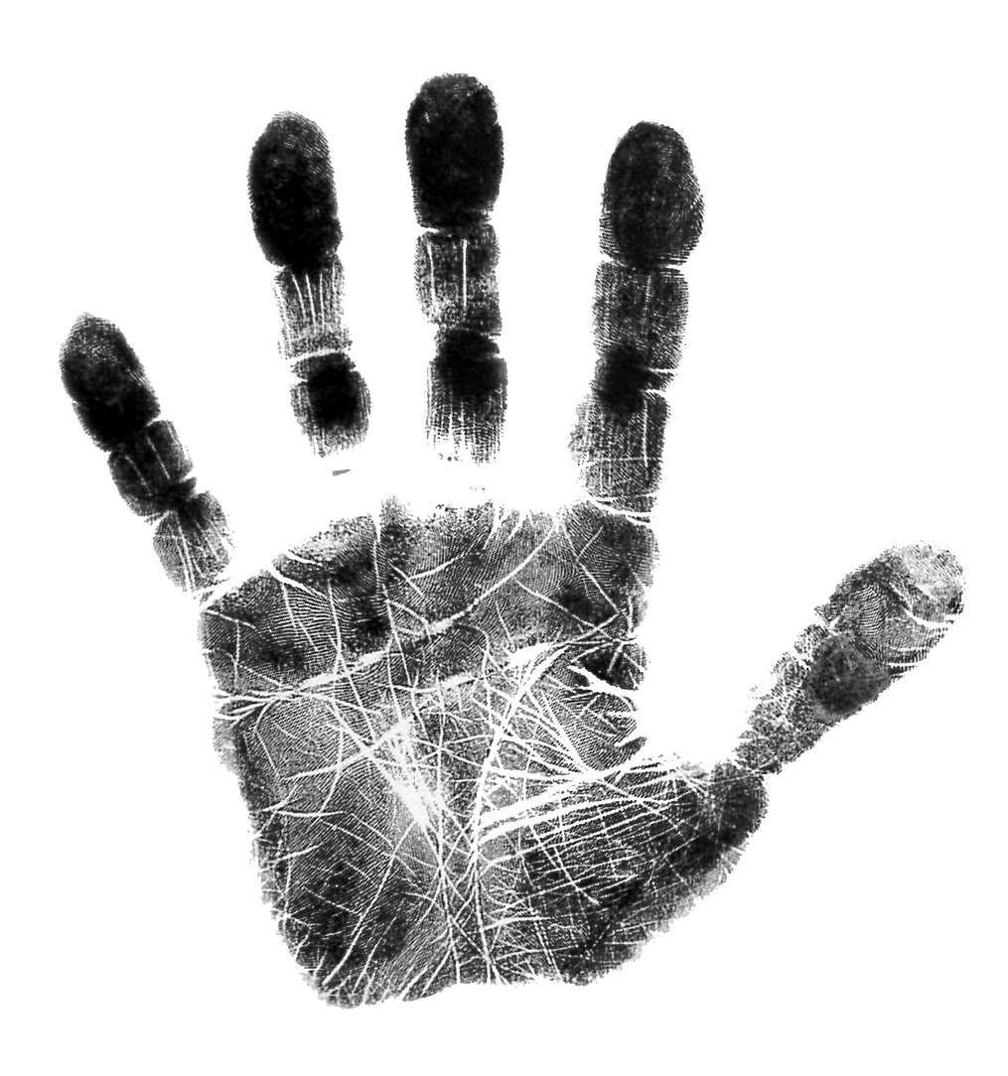
Fingerprint Lab Sheet
Left Hand
Thumb | Index Finger | Middle Finger | Ring Finger | Little Finger
Type:
Right Hand
 |  |  |  | 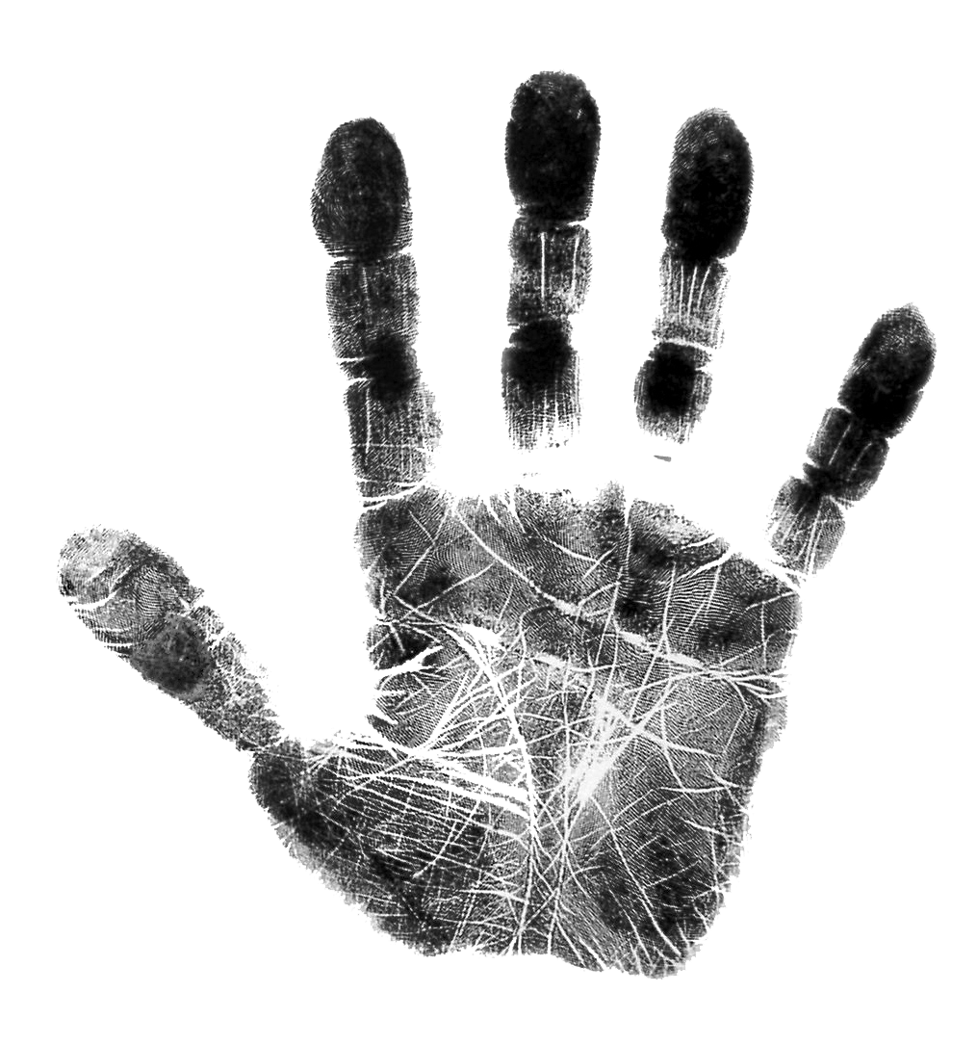
Thumb | Index Finger | Middle Finger | Ring Finger | Little Finger
Type:
Rub a number 2 pencil on a scrap sheet of paper. Rub your finger on it, and then press a piece of clear tape to your fingertip. Place the tape onto the chart above. Repeat with each of your fingers. Use your fingerprint classification sheet to label each type of print.

Examine your prints with a magnifying lens. What do you notice? Are all of you fingerprints the same type? How many different types do you see?

