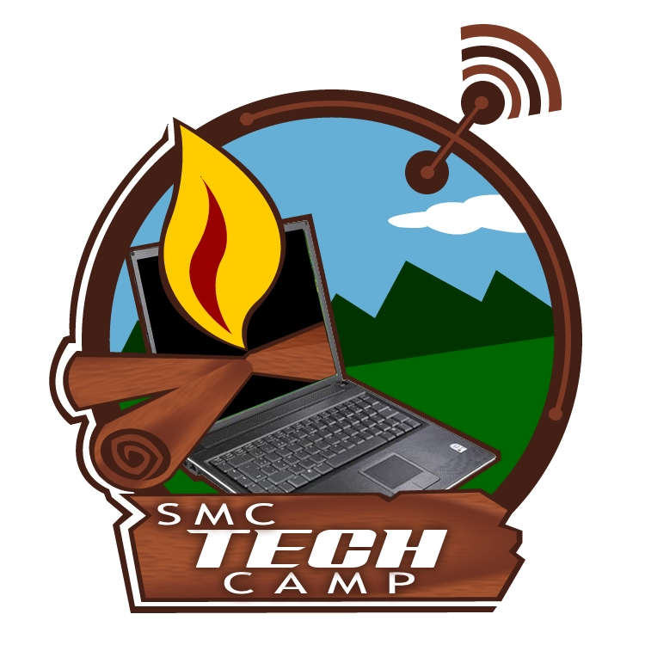
Digital Day Camps
Enhancing Technology Experiences
HSTI – June 16 & 17

Who are we?

Kristy Graham – 3rd Grade Teacher – SMC @ Keiser
Eva Griffin – 5th Grade Teacher – SMC @ Wilson
Dana Lane – Technology Coordinator – South Mississippi County School District

What is a digital day camp?

A digital day camp is a fun-filled themed day that immerses kids in technology.
The theme enables us to build continuity in our activities and makes the day a true experience.

Why offer digital day camps?

Our parents want their children to have learning opportunities outside the normal school day.
We want to extend our students’ technology experiences to prepare them for today’s world.
We love technology and kids!

How can you use our ideas to create your own camp?

Sit back as we walk you through two camps – Technology Treasures & Tech Studio.
Jot down notes and ideas as we go.
Gain access to our SMC Technology Camps website with detailed information and links.

How can you modify our camps to fit your needs?

All technology projects can be modified for the software that you have available.
The camp activities are easily adaptable to various ages.
The day camp format works for us. However, our ideas can be implemented in other ways.

What if you have questions after today?

Feel free to use the “Contact Us” section of our website.
Email Dana Lane – dana.lane@smc.k12.ar.us.
Notes





